CSE598 Assignment 1

In this assignment, we are going to develop models for application of handwritten digit recognition using TensorFlow and MNIST dataset.

**Task 1(file a1a.py)**

Use logistic regression to classify image of handwritten digits.

First, implemented functions from utils.py to read the MNIST dataset into numpy arrays. Then, Process the train and test data in batches to reduce running time since we have massive data. Last draw samples from iterating the two datasets and compute loss and accuracy for training data and testing data after each epoch.

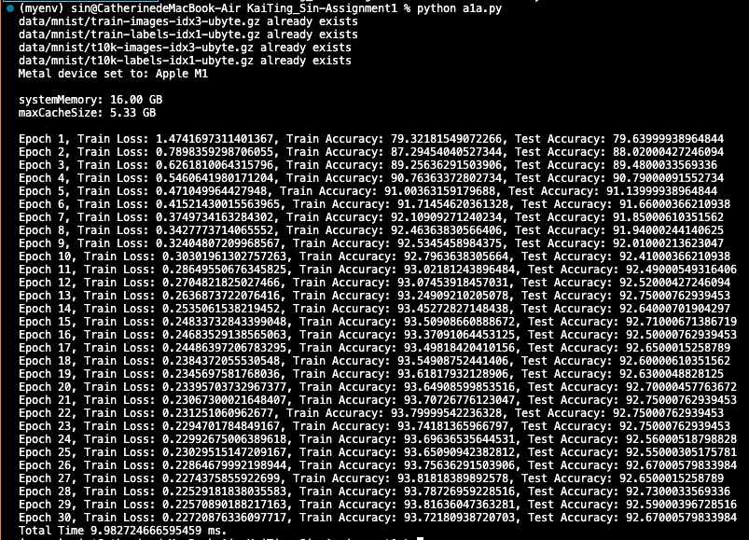

TensorBoard:

The best accuracy is about 92%. Time spent on completing this task is about 5-6 hours including debugging and environment setting.

**Task 2(file a1b.py)**

For improvement of the model of task 1, I tried to classify handwritten digits using a Multilayer Perceptron (MLP) Classifier.

First, flatten our 28x28 pixel images into a 784-length vector for each image. Then, normalized the grayscale values from 0-255 to 0-1 to reduce the complexity on computation of the neural network. Change the categories 1-9 into a binary matrix. Finally, build and fit the model then evaluate the loss and accuracy of it.



The neural network structure:

Visible Layer (784 Inputs) >> Hidden Layer (784 Neurons) >> Output Layer (10 Outputs)

TensorBoard:

With the same epochs, the MLP model has a better accuracy than the logistic regression model that is up to 98%. Moreover, the time processing spent is about 21ms, which took more time than the logistic regression model (9.85ms). It may be caused by the decrease of the batch size that I set. If epochs increase, the time spent would be more significant.

Time spent on completing task 2 is around 8-9 hours including research on method applicable on handwritten digits recognition, development of the model, visualization for Tensorboard and debugging.

**Interesting problems met during this assignment**

For the environment setting. I have encountered some problems. First is installing TensorFlow. For Apple M1 computer users, we need to install different version of the packages, including tensorflow-deps, tensorflow-macos, and tensorflow-metal, so I’m not sure if the reference list of dependencies is met. Follow the instruction on the official site, latest versions are installed. TensorFlow is also tested correctly by running the example code logreg_example.py. However, when completing the task 1 and tried to run it. I got an error message:

”tensorflow.python.framework.errors_impl.NotFoundError: could not find registered platform with id: 0x11c2f35c0 ”. I searched for solution and found out that it might be caused by mac m1 version. The problem most probably has to do with recent changes on TensorFlow side for version 2.11 where a new optimizer API has been. Thus, I dropped back to the following versions: tensorflow-macos==2.9 and tensorflow-metal==0.5.0 and the problem has fixed for now.

The other difficulty is the output of test dataset’s accuracy scalars graph in TensorBoard in task 2. Using callbacks in the fit() function of the model can log events for TensorBoard of each epoch. However, it can’t log events of each epoch for the test data in evaluate() function so that the graph epoch_accuracy, epoch_loss only contain train and validation dataset.